CS 6360.004

ASSIGNMENT 3

Names of student: Pritom Das Radheshyam

Topic: Creating the Database

Tool Used: Microsoft SQL Server Management Studio 2018

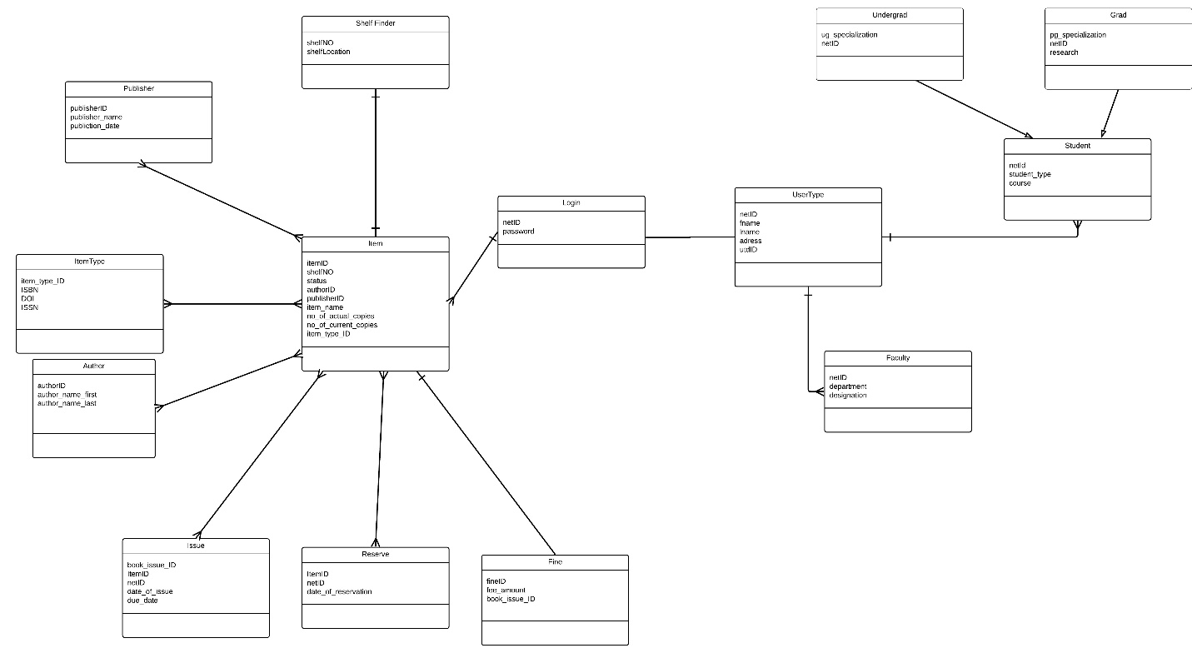

UML Diagram for the Proposed Database Design of a Library Management System. The relationships are also explained along with it.

The database diagram generated by the used tool:



Indexes Used in this Database:

* Netid
* Author First Name
* Author Last Name

Reasons:

1. Netid is one of the most used primary key to search any query from finding which students borrowed books to even reserving an item from the library. Indexing on that will definitely result in faster query execution.
2. Most times, students use author names to find a book faster. Although a library can possess various kinds of items, but generally it is going to have a huge collection of hard copy versions of the books. So indexing in author names can help in searching where the book is stored physically even faster.

Subclass/Superclass Relationships:

*Student*

* Undergrad
* Grad

Since Graduation students can have different types of specializations and at the same time have different rules on policy for borrowing time from the library, I have separated the students into two different tables and put them under the superclass “Student”